ACCUKNOX – ASSIGNMENT 2
Problem Statement 2

Anish Sarkar
B.Tech (AI & ML), Netaji Subhash Engineering College, Kolkata
GitHub: https://github.com/ans036

Referenced work: Doyen Diagnostics ML internship, Schizophrenia EEG, chronic-disease DB.

========================================
Q1. SELF-RATING ON LLM, DEEP LEARNING, AI, ML
========================================

I'll use the A/B/C scale and anchor each rating to things I've actually done.

Machine Learning – A (can code independently)

My Doyen Diagnostics internship revolved around an end-to-end ML pipeline for disease-burden prediction and health-score modeling. I handled data prep, model training (including semi-supervised DNNs with label propagation and Gaussian kernels), and evaluation, not just dropping a model into a notebook.

Deep Learning – A

Deep models show up in almost every project: a Chrononet-style CNN for EEG classification, a two-stream spatio-temporal network for highway-traffic CCTV, and scientific ML work on tumor-immune dynamics. I'm comfortable writing custom architectures, debugging training, and reasoning about overfitting and data leakage.

LLM – A (borderline A/B, but I'll own A)

During my Software Developer Internship at Jadavpur University, I built LLM-based NLP applications to improve learning comprehension and launched an AI word-building game that engaged 123 users, which forced me to think about prompt-design, context management, and response shaping, not just calling an API. I've also experimented with small RAG/chatbot setups on open-source models.

AI (general) – B

I've covered search, planning, RL basics, and classical AI ideas in coursework, and I can implement basic algorithms, but my strongest experience is clearly in data-driven ML and LLM applications. So I'd rate myself B here.

Self-Rating Table -

Area | Rating | Short reason
ML | A | Built and deployed end-to-end pipelines, including semi-supervised disease-burden modeling.
Deep Learning | A | CNNs for EEG/video, DNNs for health scores, scientific ML for tumor-immune dynamics.
LLM | A | Built LLM-based apps and games, comfortable integrating APIs and building small RAG-like flows.
AI (general) | B | Understand and can implement core concepts, but less production experience compared to ML/DL.

========================================
Q2. HIGH-LEVEL ARCHITECTURE FOR AN LLM-BASED CHATBOT
========================================

If I had to pitch an LLM-based chatbot to a teammate, I'd describe it as "a chat UI on top of an LLM, with a brain in the middle that knows when to call tools and when to just generate text."

Components

1. Frontend / chat UI

Could be a simple React web app or even a Slack bot.
Handles authentication, sends user messages to the backend, displays responses and streaming tokens.
UX-wise this is similar to the UI side of my AI word-building game, just with a chat layout instead of game tiles.

2. Backend API service

A small FastAPI/Flask service exposing /chat.
Receives {user_id, message, session_id}, does logging, and orchestrates the rest.
Good place to enforce rate limits and input validation.

3. Conversation state

Short-term state: last N turns of the conversation stored in Redis or any fast store.
Long-term state: user profile, preferences, maybe prior tasks, stored in a DB.
The backend decides how much history to send to the LLM to keep context without blowing up token counts.

4. Knowledge and retrieval (RAG layer)

For a company like AccuKnox, the chatbot should answer questions grounded in internal documentation and security findings, not just "what the LLM thinks."

Offline:
• Ingest docs, runbooks, FAQs, policy descriptions, and sample alerts.
• Chunk them and embed each chunk using an embedding model.
• Store embeddings + metadata (tenant, severity, product area) in a vector DB.

Online:
• For each query that looks like a knowledge question, embed the user message.
• Query the vector DB with filters (e.g., tenant_id and product=CNAPP) and pull top-k relevant chunks.
• Add those chunks into the LLM prompt.

5. LLM engine

The actual model, served via an API (OpenAI, Anthropic, or an internal model hosted with something like vLLM).
The backend wraps it with:
- System prompt ("You are a security assistant…")
- Conversation history
- Retrieved context (from the RAG layer)
- The current user message

6. Tools / function calling

To go beyond static Q&A, the model can call tools:

• get_current_alerts(tenant_id, severity)
• describe_policy(policy_id)
• run_k8s_check(cluster_id)

The backend executes these functions (real REST calls, SQL queries, etc.) and feeds the results back into the LLM. Conceptually it's not that far from how we chained OCR → text cleanup → TTS in Bongo Shruti; here the orchestrator is the LLM plus some routing logic instead of a fixed pipeline.

7. Safety, logging, and monitoring

• Content filters for sensitive outputs.
• Logging for prompts, responses, and tool calls (with PII scrubbing where needed).
• Metrics like latency, token usage, and failure rates to continuously improve prompts and retrieval logic.

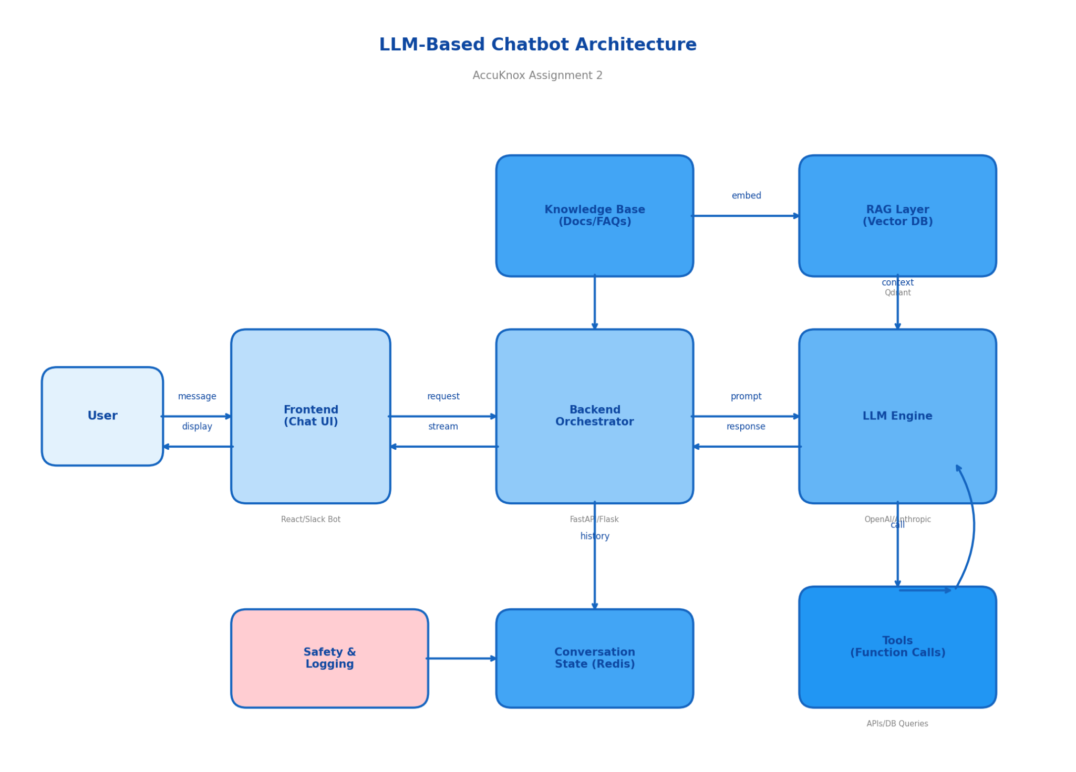

========================================
Q3. VECTOR DATABASES AND CHOOSING ONE FOR A HYPOTHETICAL PROBLEM
========================================

What a vector database is (in my own words)

When you embed text (or images, audio) into vectors, you move from keyword space into a high-dimensional numerical space. A vector database is built to store those vectors and quickly answer questions like "which existing pieces of text are most similar to this new query embedding?" instead of "which rows match this exact word."

Typical features:

• Efficient approximate nearest-neighbor search (HNSW, IVF, etc.).
• Support for metadata filters (e.g., only search within a specific tenant or time range).
• CRUD on vectors and metadata.
• Horizontal scale and durability for large corpora.

Hypothetical AccuKnox-style use case

Imagine we're building a "Cloud Security Copilot" on top of a CNAPP.

• It should answer questions like:
- "What are my top 5 critical misconfigurations in production this week?"
- "Explain this eBPF-based anomaly in simple terms and give me a fix."

• We have:
- A stream of findings and alerts with descriptions and YAML snippets.
- A corpus of runbooks, FAQs, and internal docs.
- Multi-tenant data that must never leak across tenants.

Why I'd pick Qdrant

For this, I'd choose Qdrant as the vector database.

• It is an open-source vector DB focused on similarity search and RAG workloads, with HNSW indexing built in.
• It supports rich payloads and filters, so I can tag every vector with fields like tenant_id, cluster, severity, source and filter queries accordingly.
• It can run as a managed service or fully self-hosted, which is important for security workloads where data often needs to stay inside a VPC or on-prem.

How it fits into the pipeline

1. Ingestion / indexing

Periodically ingest alerts, policies, and docs from the CNAPP.
Chunk text and generate embeddings (e.g., using a sentence-transformer).
Upsert into Qdrant with metadata: {tenant_id, resource_id, severity, created_at, type}.

2. Query time

Take the user's natural-language question, embed it.
Query Qdrant for top-k neighbors with filters like tenant_id = current_tenant and severity ∈ {HIGH, CRITICAL}.
Pass the retrieved text into the LLM context along with the question.

3. Answering

The LLM reads the retrieved context and responds with an explanation plus remediation steps, similar to how I used model outputs plus narratives in my tumor-immune dynamics work.

For smaller research experiments or offline notebooks, I'd still happily use FAISS directly in Python, but as soon as I need multi-tenant metadata, durability, and a clean API, a purpose-built vector DB like Qdrant feels like the right abstraction.

